## **Software Testing**

**Software Testing** is a method to check whether the actual software product matches expected requirements and to ensure that software product is[Defect](https://www.guru99.com/defect-management-process.html)free. It involves execution of software/system components using manual or automated tools to evaluate one or more properties of interest. The purpose of software testing is to identify errors, gaps or missing requirements in contrast to actual requirements.

Some prefer saying Software testing definition as a [White Box](https://www.guru99.com/white-box-testing.html) and [Black Box Testing](https://www.guru99.com/black-box-testing.html). In simple terms, Software Testing means the Verification of Application Under Test (AUT). This Software Testing course introduces testing software to the audience and justifies the importance of software testing.

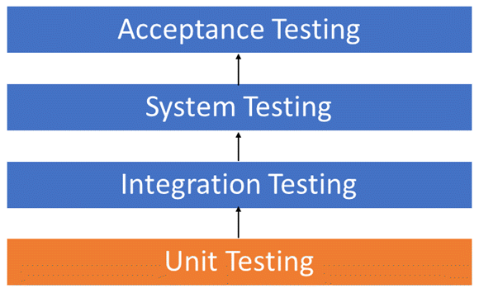

**Benefits of software testing:**

* ****Cost-Effective:****It is one of the important advantages of software testing. Testing any IT project on time helps you to save your money for the long term. In case if the bugs caught in the earlier stage of software testing, it costs less to fix.
* ****Security:****It is the most vulnerable and sensitive benefit of software testing. People are looking for trusted products. It helps in removing risks and problems earlier.
* ****Product quality:****It is an essential requirement of any software product. Testing ensures a quality product is delivered to customers.
* ****Customer Satisfaction:****The main aim of any product is to give satisfaction to their customers. UI/UX Testing ensures the best user experience.

# **Unit testing**

Unit testing is a [software](https://www.techtarget.com/searchapparchitecture/definition/software) development process in which the smallest testable parts of an [application](https://www.techtarget.com/searchsoftwarequality/definition/application), called units, are individually and independently scrutinized for proper operation. This testing methodology is done during the development process by the software developers and sometimes QA staff.  The main objective of unit testing is to isolate written code to test and determine if it works as intended.

* Unit tests help to fix bugs early in the development cycle and save costs.
* It helps the developers to understand the testing code base and enables them to make changes quickly
* Good unit tests serve as project documentation
* Unit tests help with code re-use. Migrate both your code **and** your tests to your new project. Tweak the code until the tests run again.

## **Integration Testing**

**INTEGRATION TESTING** is defined as a type of testing where software modules are integrated logically and tested as a group. A typical software project consists of multiple software modules, coded by different programmers. The purpose of this level of testing is to expose defects in the interaction between these software modules when they are integrated

Integration Testing focuses on checking data communication amongst these modules. Hence it is also termed as ****‘I & T’**** (Integration and Testing), ****‘String Testing’**** and sometimes ****‘Thread Testing’****.

* A Module, in general, is designed by an individual software developer whose understanding and programming logic may differ from other programmers. Integration Testing becomes necessary to verify the software modules work in unity
* At the time of module development, there are wide chances of change in requirements by the clients. These new requirements may not be unit tested and hence system integration Testing becomes necessary.
* Interfaces of the software modules with the database could be erroneous
* External Hardware interfaces, if any, could be erroneous
* Inadequate exception handling could cause issues.

## **System Testing**

****System Testing**** is a level of testing that validates the complete and fully integrated software product. The purpose of a system test is to evaluate the end-to-end system specifications. Usually, the software is only one element of a larger computer-based system. Ultimately, the software is interfaced with other software/hardware systems. System Testing is actually a series of different tests whose sole purpose is to exercise the full computer-based system.

* Testing the fully integrated applications including external peripherals in order to check how components interact with one another and with the system as a whole. This is also called End to End testing scenario.
* Verify thorough testing of every input in the application to check for desired outputs.
* Testing of the user’s experience with the application.

# **Acceptance Testing**

**ACCEPTANCE TESTING**is a level of software testing where a system is tested for acceptability. The purpose of this test is to evaluate the system’s compliance with the business requirements and assess whether it is acceptable for delivery (or writing that big check).

**acceptance testing**Formal testing with respect to user needs, requirements, and business processes conducted to determine whether or not a system satisfies the acceptance criteria and to enable the user, customers or other authorized entity to determine whether or not to accept the system.